# **Introduction**

This report analyzes health data from multiple healthcare facilities in Pakistan to identify key demographic trends, common diseases, and the relationship between patient age and treatment costs. The dataset includes patient age, gender, disease diagnosis, and treatment costs collected over one year. The aim is to provide insights that can help improve healthcare resource allocation and policy-making in Pakistan. The data covers a one-year period and aims to provide insights into healthcare trends and costs.

# **Objective**

The objective of this report is to analyze health data from Pakistan to identify key demographic trends, understand the distribution of common diseases, and examine the relationship between patient age and treatment costs.

# **Data Overview**

The dataset comprises records of patients treated in various healthcare facilities across Pakistan. Key variables include age, gender, disease, admission date, discharge date, blood group, and treatment cost. The data covers a one-year period and aims to provide insights into healthcare trends and costs.

# **Tools**

For analyzing this dataset, we use:

* MS Excel

# **Methodology**

For Pivot table we selected the whole dataset then then choose Pivot table option, in the new worksheet for pivot table we put columns in the Field list after making the pivot table highlight the table go to insert then select chart.

# **Key Insight**

After analyzing the dataset, we were able to determine couple of visual like:

* Age Distribution
* Hospital Statistics
* City-wise Patient Count
* Treatment Cost by Hospital
* Patient Age vs. Treatment Cost

## **Age Distribution:**

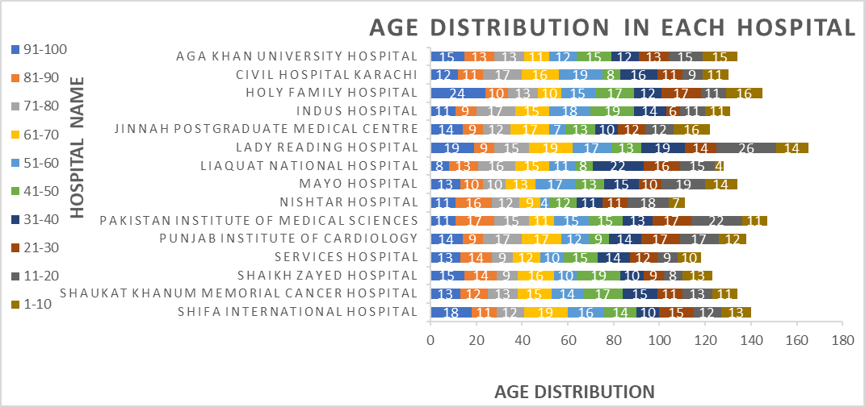

Youngest Patients (1-10): **Jinnah Postgraduate Medical Centre (16 Patients)** and **Holy Family Hospital (16 Patients).**

Oldest Patients (91-100): **Holy Family Hospital (24 Patients).**

## **Hospital Statistics**

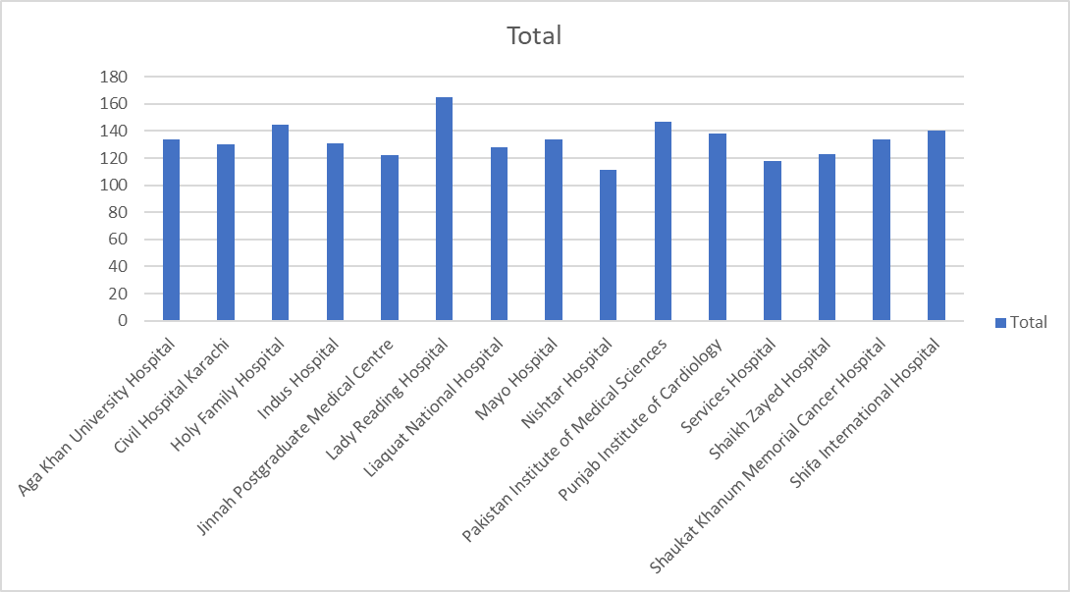

After examine **Lady Reading Hospital** had the greatest number of patients (165) and **Nishtar Hospital** had least number of patients (111) throughout whole year.

## **City Wise patients**

After examine **Multan** had the greatest number of patients (268) throughout whole year which tells us that people are sick and they not taking care of their health.

## **Treatment Cost by Hospital**

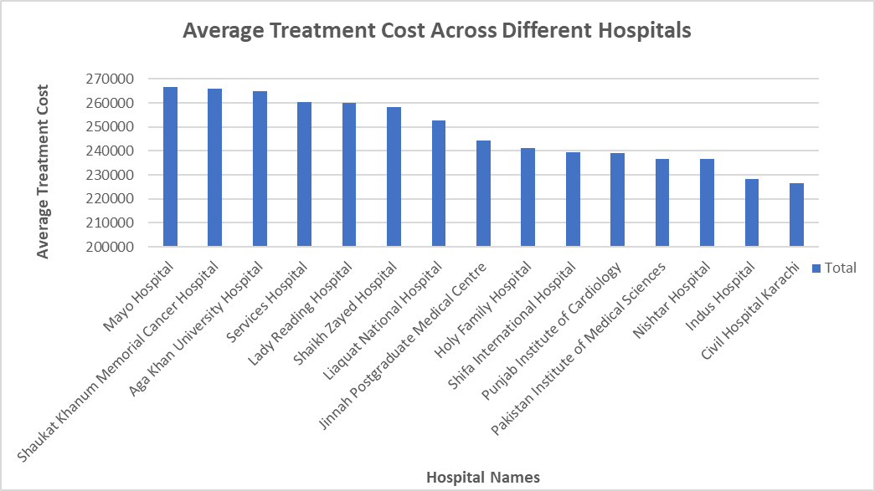

**Mayo Clinic’s** average treatment cost is the highest which is 266666PKR whereas **Civil Hospital Karachi** average cost is the lowest which is about 226452PKR.

## **Patient Age vs Treatment Cost**

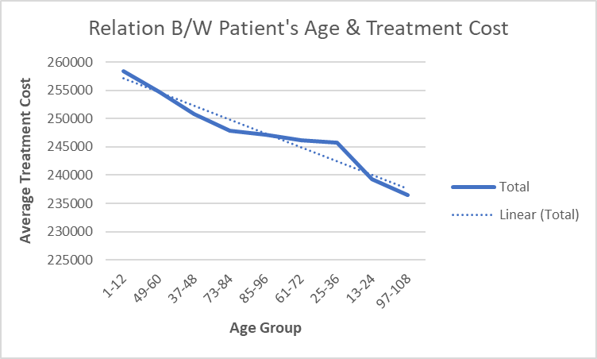

After examine of the data set, we came to conclusion that there is direct correlation between patient age and average treatment cost that is due to large number of patients from group age “youngest (1-12)” the average treatment cost is the highest which is 258340PKR.

# **Conclusion**

The analysis of the health data reveals significant trends in treatment costs. Younger patients tend to incur higher treatment costs, and common diseases such as diabetes and hypertension are prevalent. These insights can aid in better resource allocation and policy-making in the healthcare sector.